Annual Report and Accounts
of the Parochial Church Council of the Ecclesiastical Parish of
East Dean, Singleton and West Dean
HMRC ref.no: XT11880
For the year ended 31st December 2021
(covering the Valley Parish villages of Binderton, Charlton, Chilgrove, East Dean, Singleton & West Dean)

I 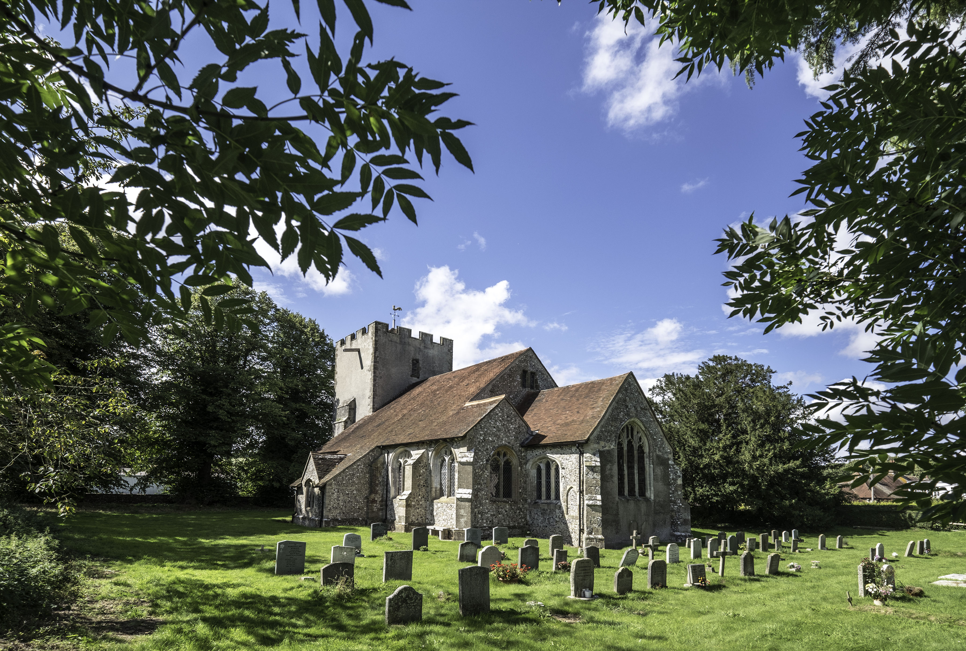
Contents:
- Trustees’ Annual Report
  - Our aims as a charity
  - Achievements and impact
  - Structure, governance and management

- Annual Financial Report
  - Financial Review
  - Statement of Receipts and Payments
  - Statement of Assets and Liabilities
  - Notes to the Accounts

- Independent Examiner’s Report

East Dean, Singleton and West Dean HMRC reg no XT11880
1. Trustees’ Annual Report

  - Our aims as a charity

The Parochial Church Council (PCC) has responsibility to:
- Promote the Gospel of our Lord Jesus Christ according to the doctrines and practices of the Church of England.
- Promote in the parish the whole mission of the church, pastoral, social, evangelistic and ecumenical.
- Give practical support and care to all people in our parish particularly those in need.
- Encourage financial giving to those in need both inside and outside our parish.
- Care for and protect our three historic parish churches known as All Saints’, East Dean; Blessed Virgin Mary, Singleton and St Andrews, West Dean and keep them open for the purpose of regular worship and welcoming the many visitors to our area.
- Protect and maintain each of the churchyards under our care.

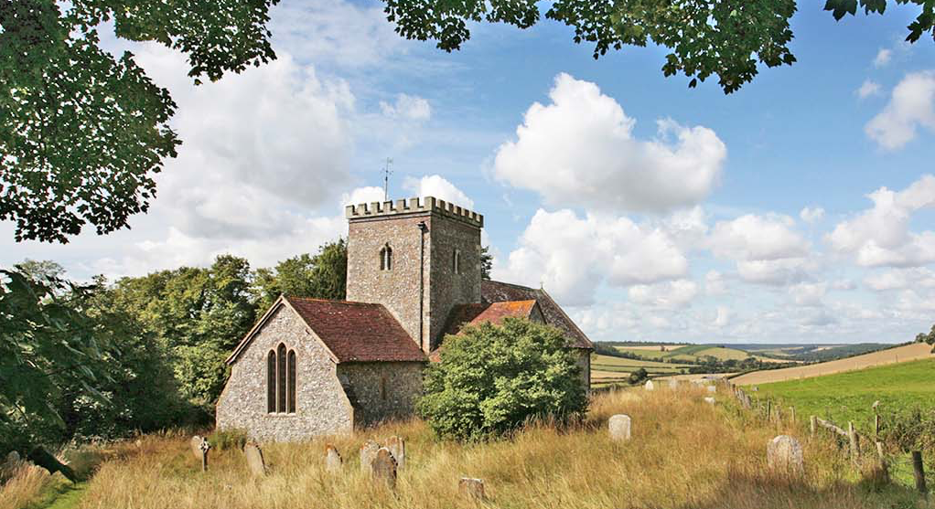

1.2 Achievements and Impact
We are a small parish in terms of numbers of residents, but large in geographical area. Much of the parish is farmland or woodland, and most of the parishioners are concentrated in the three larger villages, with several also resident in outlying areas of the parish. Travel and communication between the villages and the three different churches can present a challenge. The Sunday services moves on rotation between the three churches, and despite the difficulties in travel, a large number of the congregation do attend worship in all three churches, and we have regular worshippers from outside the parish.
We have drawn up a Mission Action Plan, which is the first step to increasing the involvement of all PCC members in the work of the Parish. Our activities have been very much curtailed by covid restrictions, but we have nevertheless maintained our congregation numbers and look forward to a positive future for the parish.

Ministry and Community
The Covid 19 Pandemic has continued to affect the life of the church in different ways during the past year.
- In September we were able to celebrate the arrival of our new parish priest, Reverend Sarah Manouch, on the year’s anniversary of her licensing. We held a short service of thanksgiving followed by a party at West Dean Gardens café, kindly hosted for us by the Edward James Foundation.
- ‘All Stars’ Junior Church which normally meets once a month led by Sarah Peirson and Sarah John, had to stop for many months due to the Covid restrictions. It has recently started again with a good number of children. Some of the children also take an active part in the monthly Family Service, in reading and offering prayers.
- The church continues to support the community Valley Diary both financially and in producing a church page, which provides information on our monthly programme of services and activities to a circulation of 800 homes within the Valley.
- Weekly prayer meetings have continued (in both live and virtual forms as allowed by lockdowns.)
- Following the retirement of our choir leader last year, the choir has not rehearsed or sung regularly but does provide music on an ad hoc basis for some services, especially festivals and weddings.
- Two of our churches are open daily, and one two days a week, to allow visitors to come in to pray and worship, enjoy the peace and serenity or to appreciate the simple yet beautiful architecture of our rural church buildings. This is managed by a rota of willing key holders and we often receive positive comments on how welcome visitors feel when they find the churches are open.
- The Rector’s weekly newsletter, Rector’s Ramblings, continues to be circulated to members of the congregation, and also others in the Valley and beyond and has a circulation of 66 people. It is also posted on all the church notice boards and is available on the parish website.
- The new card reader is not particularly user-friendly, and we are looking at updating it, and other ways of increasing income, which has dropped dramatically during the lockdowns.
- Our two Church of England Controlled Primary Schools continue to thrive. A new headteacher started in the autumn term at West Dean school, and Singleton school has also welcomed a number of new staff members. The PCC has appointed Foundation Governors to both schools. A Harvest Festival and a Christingle service was held in St Andrew’s West Dean for the children of West Dean School. Unfortunately Singleton School has been badly affected by Covid and so restrictions made a church visit impossible, but a Harvest Service was held in the school. Both schools collected for the local Food Bank.
- Once again, all the usual events and activities beyond Church services had to be cancelled due to Covid.
- The annual St Roche’s service took place on 16th August, but once again it was decided to hold it as an outdoor service in the churchyard at Singleton. Lent and Easter: an online Lent Course was held via Zoom and had an average attendance of between 8 – 12 people. We were excited to be able to return to in-person worship for Palm Sunday, and on Easter Sunday a large all age congregation gathered outside the church after the service to sing Thine Be the Glory, as a joyful witness.

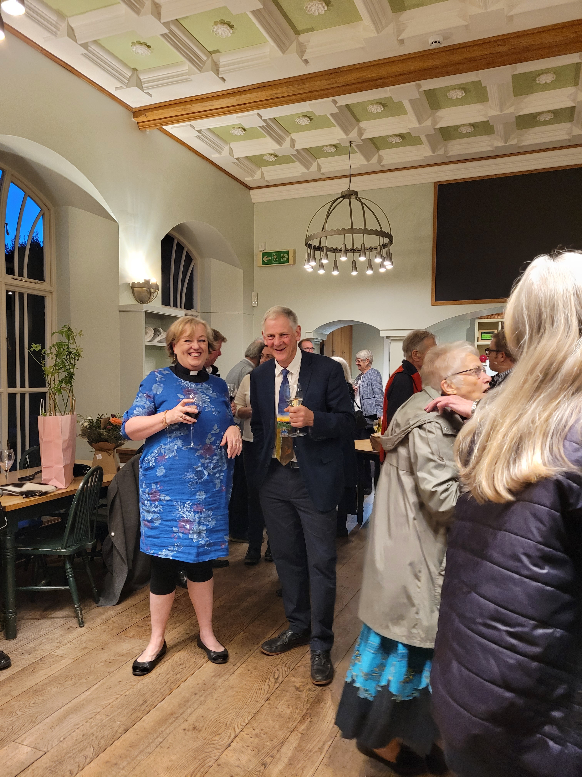

Christian Outreach and Parish Giving

- Rev Sarah visits local housebound residents to provide communion and company on a regular basis. She makes good use of the website to recommend online resources available to anyone.
- One member of our PCC who is a qualified ALM has continued to be available by phone and email contact for anyone who might need to talk.
- Rev Sarah is one of the trustees of the Henry Smith Trust and the Singleton Sickness Fund, which helps local residents. The Churchwardens and Rev Sarah are trustees of the Bowles Cottage Trust which helps the two church schools.
- Our regular Community Café, run in Singleton once a month, had to be stopped for several months but will start again in 2022.
- There have been 2 weddings for those who live within or have a connection with the parish, 2 baptisms have taken place, and 3 funerals .
- Gifts at Harvest have gone to help the Chichester Foodbank, and collection boxes for this are placed permanently in all three church porches. Our St Roche’s day collection was for HASAG (Asbestos Disease Support) and we have also supported Médecins sans Frontieres.
- We have also recently started providing collection boxes for recycling of ‘hard to recycle’ items such as pens and cosmetics, doing our bit for the environment.
- Some members of the congregation went carol singing before Christmas round East Dean, which was very much welcomed by residents and raised funds for the local foodbank.

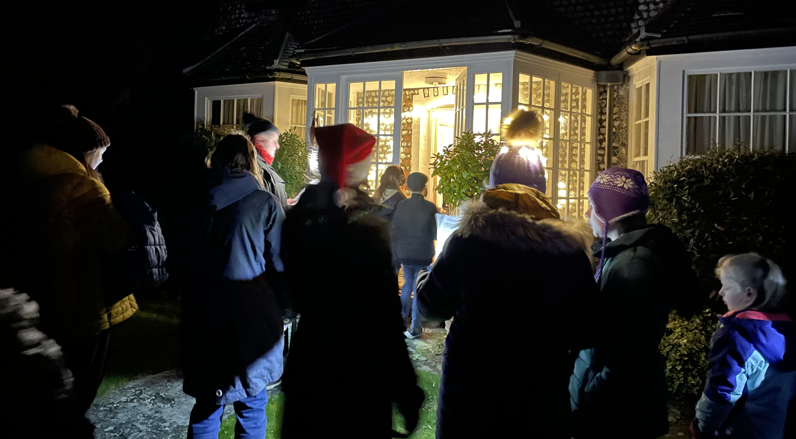

Management of church buildings and churchyards
A small team of dedicated volunteers has continued to keep our three churches clean and tidy as and when covid restriction rules have allowed.

St Andrews, West Dean
- No further progress has been made towards fulfilling the 2019 quinquennial inspection action plan.
- A small area of ceiling collapsed in the vestry. A list B application has been approved by the Archdeacon and authorization has been given for the necessary repairs to be carried out.
The Blessed Virgin Mary, Singleton
- The delayed quinquennial inspection took place this year and a full report has been received from the architect.
All Saints, East Dean
- The scheduled quinquennial inspection took place this year and a full report has been received from the architect.
Churchyard Maintenance
West Dean Parish council takes responsibility for the maintenance of St Andrew’s churchyard and keeps it well trimmed and tidy. Maintenance of the Blessed Virgin Mary and All Saints churchyards are the responsibility of the PCC and the mowing follows an agreed plan to encourage wildlife and natural diversity.

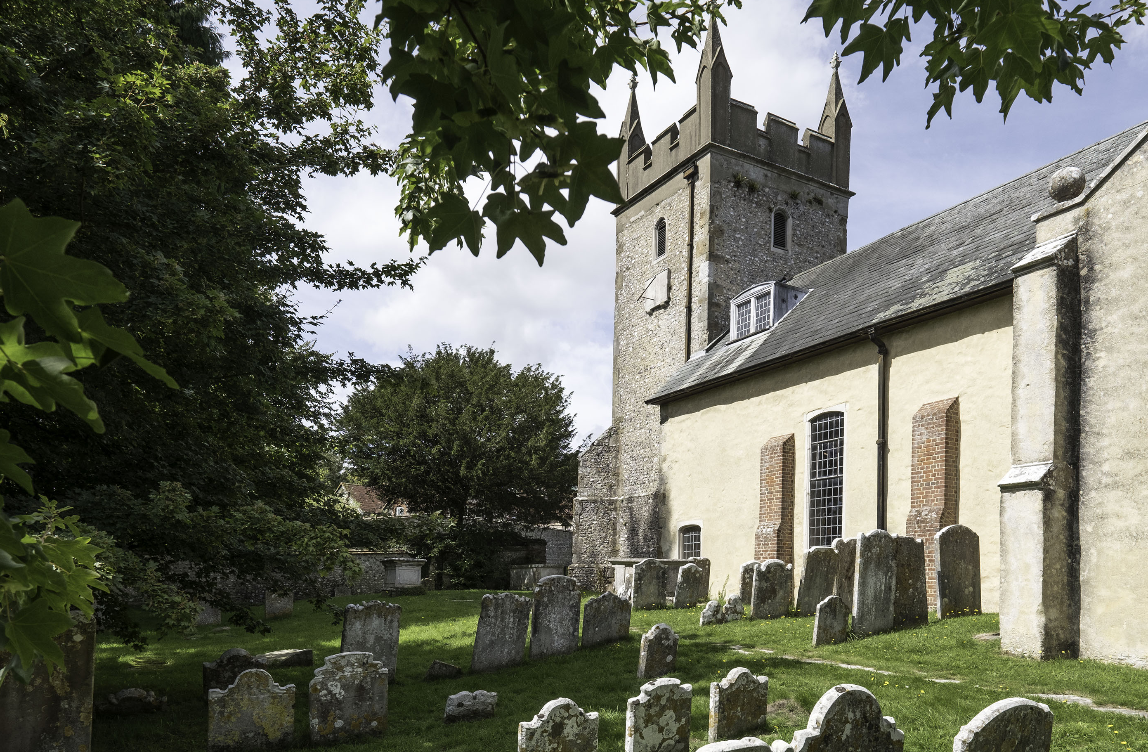

  - Structure, governance and management of the charity

The PCC is a charity, excepted from registering with the Charity Commission within the meaning of section 30 of the Charities Act 2011. Its governing document is the Parochial Church Councils (Powers) Measure 1956.

The PCC has complied with section 5 of the Safeguarding and Clergy Discipline Measure 2016, by having due regard to House of Bishops' guidance on safeguarding children and vulnerable adults.

Membership of the PCC is determined under the Church Representation Rules and consists of certain ex-officio members (the Rector, the churchwardens and members of the Deanery Synod) and ten members of the church who are elected at the Annual Parochial Church Meeting (APCM). During the year the following served as members of the PCC:

Rector: Reverend Sarah Manouch BA
Churchwardens: Wendy Goacher, John Holt
Deanery Synod: Geoffrey Morris
Elected Members: Wendy Heather; Karen Searle Barrett; Richard Stephens; Oliver Peirson; Helen Morris; Jennifer Neelands; Thomas Shaw; Matthew Coughlan; Serena Colchester; Sarah John

Safeguarding Officer: Sarah Peirson
Independent Examiner: Miles Barber

The Annual Report was approved by the PCC on 8th March 2022 and signed on its behalf by the PCC Chairman

Signed……………………………………………………………….. Date …………………………………………………….

